Sustainability Initiative Part 4: Team assignment

CREATING A SUSTAINABLE LEGACY: HEALTHY COMMUNITIES/MHA/560

By: Merna Ayad, LaCreasha Banks, Forell Bering, Dr. Frank Biondolillo, Kristy Burns,

Yadira Castro, and Austin Wolf

January 29, 2021

Instructor: Helen Cole

Waste Generated in the Health Care Industry

As we elaborate on waste, it is important to know that most of the waste produced

in the United States is considered non-hazardous. However, when we focused in the Health care

industry we find that there are many different types of waste. For example, Infectious,

pathological, sharps, chemicals, pharmaceuticals, genotoxic, radioactive, and non-hazardous

waste. Education is extremely important for the employees in the health care field. In this

infographic assignment we will provide information on each type of waste.

Infectious
Pathological
Sharps
Chemicals
Pharmaceuticals
Pharmaceutical waste can include medical waste, solid waste or hazardous waste and impacts every department in a hospital. Hospitals generate on average $200,000 dollars’ worth of drugs annually. These drugs cannot be thrown in the trash or flushed into the water systems as it can be found in water supplies and have adverse effects on the environment. The hospital works with reverse distributors to take the unused drugs and dispose of them safely. There are kiosks in areas within the hospital to accommodate for the transfer of unused drugs to the reverse distributors.
Genotoxic
Genotoxic waste is a type of medical waste that can be highly hazardous. It includes waste containing substances which can have properties which are mutagenic, carcinogenic or even teratogenic. It can include waste materials from drugs which are cytostatic or vomit after taking cytostatic drugs, (Székely et al, 2011). The genotoxic waste can also come from feces or urine of patients treated with these drugs as well as chemicals and materials which are radioactive. Pharmaceuticals have also included the use of drugs which are anti-cancer in treating different types of diseases which are considered to be genotoxic. People can be exposed to these materials when treating patients or people working in the production plants and hospitals. Incineration is the proffered disposal method for disposing genotoxic waste. Non incineration methods of disposing the genotoxic waste include sterilization of the waste which may be infectious.
Radioactive
Non-Hazardous or General Waste
Non-Hazardous waste is the highest percentage of waste in the medical field. We want to ensure that team members can differentiate between hazardous and non-hazardous. This type of waste causes significant environmental impact if we do not dispose of it correctly or consider recycling. Many state and federal agencies regulate this type of waste as well. What is considered non-hazardous waste can vary by state. This waste cannot be contaminated with any bodily fluids and it must be clean. Clean plastic, glass, cardboard, aerosol containers and other items vary by state are examples of non-hazardous waste. It is important to have a waste management program that would incorporate recycling processes along with efficiency protocols to reduce trash. The purchasing department can ensure that when materials are purchased as part of their sustainability goal they seek for reusable, recyclable packaging. We must ensure that we have trash containers as well as recyclable containers throughout our facilities. We must evaluate what is being discarded and educate the staff and provide information regarding the findings.
Summary:

Waste Category | Description and common types | Sources | Generated yearly | How do we dispose of it? | How do we reduce?
Infectious
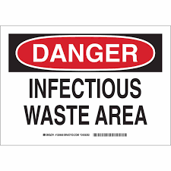
Pathological
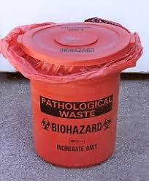

Sharps
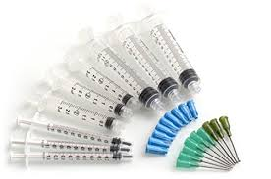

Chemicals
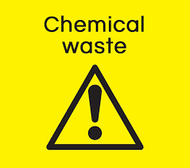

Pharmaceuticals  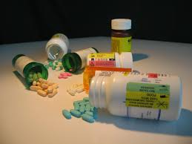 | Can be regulated medical waste, solid waste, or hazardous waste | All departments throughout the hospitals and healthcare facilities | 200k expired drugs annually. | Reverse Distributor Pharmaceutical kiosk and mail back coordinated onsite. | Do not throw in trash or down the drain. This is proven to be harmful to the environment, and water supply. Reverse distributor kiosks onsite.
Genotoxic  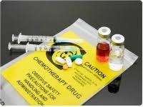 | Hazardous waste materials which are mutagenic, carcinogenic or teratogenic. | Waste materials from drugs which are cytostatic or patient vomit after taking cytostatic drugs | There is 0.56 to 98.3 kg of waste generated per bed each year | Incineration is the preferred disposal method as well as non-incineration methods like hydroclave and autoclave for waste sterilization. | Maintaining proper hygiene in areas where cytostatic drugs are used as well as proper storage and transportation of the waste before disposal.
Radioactive
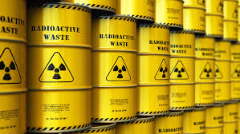

Non-Hazardous or General Waste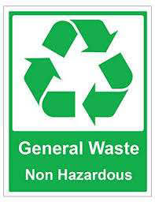 | Examples of Non-hazardous waste include plastic packaging, clean plastic, boxes and glass. In certain states aerosol cans are not hazardous if these are completely empty. | All departments throughout the hospitals and healthcare facilities | 85% of the generated waste in the Medical field falls under this category | Ensuring that it is non-hazardous, recycle, work in conjunction with a disposal company that specializes in non-hazardous waste | We reduce waste by ensuring that we look at all our options on efficiency and identify properly what is trash vs what is not

Generated
Waste
Radioactive
Figure 1

References

Environmental Protection Agency (Aug, 2008). Unused Pharmaceuticals in the Health Care Industry. EPA Interim Report. https://www.epa.gov/sites/production/files/2015-11/documents/unused-pharms-health-care_interim-report_2008.pdf
Modern Healthcare (Aug 30, 2018). Reducing Pharmacy Waste and Expanding. Modern Healthcare Technology. https://www.modernhealthcare.com/article/20180830/SPONSORED/180839996/reducing-pharmacy-waste-and-expanding-roi
Székely, G., Bandarra, J., Heggie, W., Sellergren, B., & Ferreira, F. C. (2011). Organic solvent nanofiltration: A platform for removal of genotoxins from active pharmaceutical ingredients. Journal of Membrane Science, 381(1-2), 21-33.

